DESIGN AND ANALYSIS AND ALGORITHMS
ASSESSMENT TOOL 1

Name: R . Sharmila Course code: CSA0606
Reg no:192521213 Slot: B

Problem Statement
Apply the Brute Force technique using Bubble Sort on the dataset [9, 18, 27, 14, 22, 5]. Bubble Sort is one of the simplest comparison-based sorting algorithms. It repeatedly compares every pair of adjacent elements and swaps them whenever they are in the wrong order. This process is repeated over multiple passes until no more swaps are required, resulting in a completely sorted array in ascending order. The objective is to perform the sorting process pass by pass, display the intermediate arrays after each pass, count the total number of comparisons and swaps, analyze the time complexity, and verify the correctness of the final sorted output.

Objectives
- To understand the Brute Force technique and how it is applied in Bubble Sort.
- To sort the given array using repeated adjacent element comparisons.
- To observe the movement of larger elements toward the end of the array after each pass.
- To display the intermediate arrays after every pass of the algorithm.
- To calculate the total number of comparisons and swaps performed during execution.
- To analyze the best, average, and worst-case time complexities.
- To verify that the final output is correctly sorted in ascending order.

Inputs and Outputs
Input
Array = [9, 18, 27, 14, 22, 5]
The input consists of six integer values arranged in a partially ordered sequence. Some elements are already in the correct order, while others are misplaced, making the dataset suitable for demonstrating the working of Bubble Sort.
Output
Sorted Array = [5, 9, 14, 18, 22, 27]
The output is the same set of elements arranged in ascending order after performing all the required Bubble Sort passes.

Assumptions and Constraints
- The input array contains integer values only.
- The sorting order is ascending.
- Bubble Sort compares only adjacent elements during each iteration.
- The size of the array remains fixed throughout execution.
- Duplicate values are not present in the given dataset.
- Additional memory is not required because Bubble Sort performs sorting in-place.
- The algorithm continues until all required passes are completed.

Problem Analysis
The given dataset contains both sorted and unsorted portions. The first few elements are already arranged correctly, whereas the last element is much smaller and needs to move toward the beginning of the array. Bubble Sort solves this problem by comparing every pair of adjacent elements. Whenever the left element is greater than the right element, the two elements are exchanged. During every pass, the largest unsorted element gradually moves to its correct position at the end of the array. After several passes, all elements become arranged in ascending order. Although Bubble Sort is simple and easy to understand, it requires many comparisons for larger datasets, making it less efficient than advanced sorting algorithms.

Mathematical Model
Let n be the number of elements in the array.
For the given problem,
n = 6
The maximum number of comparisons performed by Bubble Sort is calculated using the formula:
Comparisons = n(n−1)/2
= 6 × 5 / 2
= 15 Comparisons
The maximum number of swaps depends on the initial arrangement of the elements. Since the given array is only partially unsorted, fewer swaps are required than in the worst case. The actual execution performs 8 swaps. The mathematical model helps estimate the computational effort required by the algorithm.

Algorithm Selection
Selected Algorithm: Bubble Sort
Bubble Sort is selected because it is one of the simplest sorting algorithms based on the Brute Force approach. It repeatedly compares neighboring elements and swaps them whenever necessary. The algorithm is easy to understand, simple to implement, and suitable for educational purposes. Although it is not efficient for very large datasets due to its quadratic time complexity, it is an excellent choice for demonstrating the concept of comparison-based sorting.

Complexity Analysis
Bubble Sort has different running times depending on the initial arrangement of the data.
- Best Case: O(n) (when the array is already sorted and an optimized Bubble Sort is used with a swap flag).
- Average Case: O(n²) because several comparisons and swaps are generally required.
- Worst Case: O(n²) when the array is sorted in reverse order, requiring the maximum number of comparisons and swaps.
- Space Complexity: O(1) because Bubble Sort performs sorting in-place without using any extra memory except a temporary variable for swapping.
The algorithm is simple but becomes inefficient as the size of the dataset increases.

Correctness Analysis
Bubble Sort guarantees a correctly sorted array because it repeatedly compares adjacent elements and exchanges them whenever they are in the wrong order. After the first pass, the largest element reaches its correct position. Similarly, every subsequent pass places the next largest element into its correct position. Eventually, all elements become sorted in ascending order. The final output [5, 9, 14, 18, 22, 27] confirms that the algorithm has successfully sorted the given dataset without losing or duplicating any element.

Results
The Bubble Sort algorithm successfully sorted the given array after five passes. During execution, it performed 15 comparisons and 8 swaps. The intermediate arrays after each pass clearly show how the algorithm gradually moves larger elements toward the end of the array while smaller elements move toward the beginning. The final sorted output is [5, 9, 14, 18, 22, 27], which verifies the correctness of the implementation.

Conclusion
Bubble Sort is a straightforward comparison-based sorting algorithm that follows the Brute Force approach. It repeatedly compares adjacent elements and swaps them whenever they are out of order. Although it requires more comparisons and has a time complexity of O(n²) in the average and worst cases, its simplicity makes it one of the best algorithms for learning the fundamentals of sorting. In this problem, Bubble Sort correctly sorted the given dataset with 15 comparisons and 8 swaps, producing the final sorted array [5, 9, 14, 18, 22, 27]. This experiment demonstrates the working principle, efficiency, and correctness of Bubble Sort in an easy-to-understand manner.
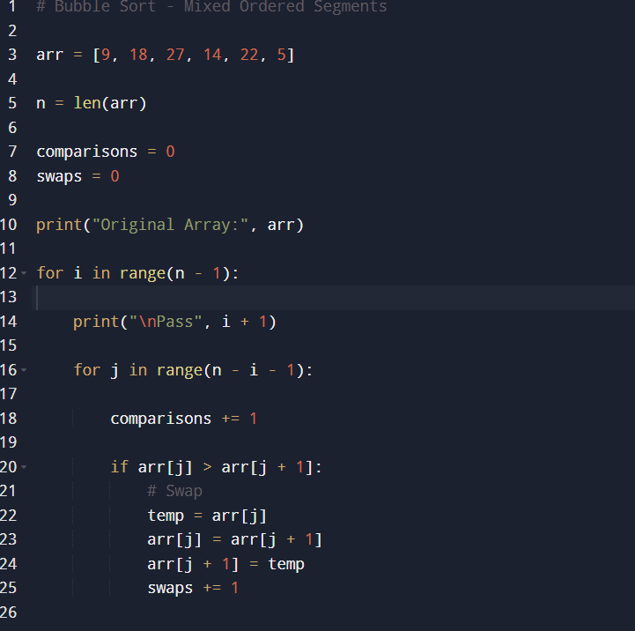

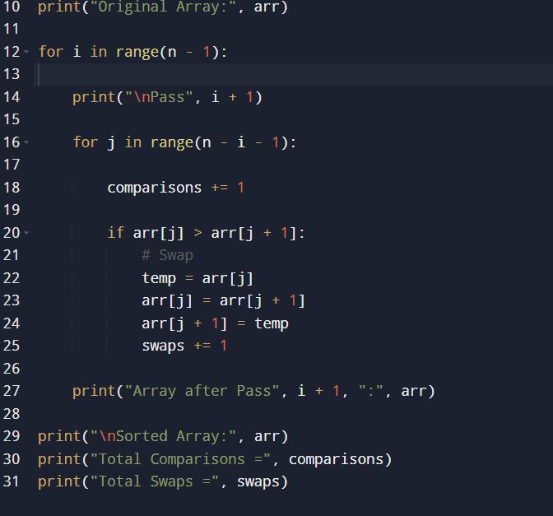

Output
